UI/UX Interfacing with Back End System

Agent

\

Http

Https

Jasper Media Data

iMedia Media Data

WCF

Jasper Media Data Transformed to iMedia Data (DTOs)

iMedia Media Data

Rest API

Crud and Query Operations

Jasper Media Data

Jasper Application

Polymer 3 Web App

WCF and MEDI

WPF iMedia Application



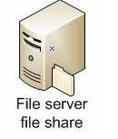



Background System